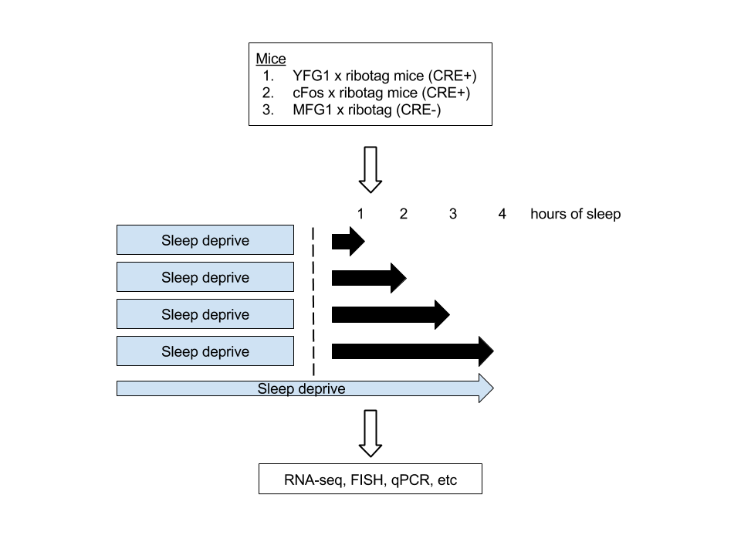Having identified that YFG1 is expressed in the brain and contains calcium response elements in its promoter, I’d be interested in testing if YFG1 has a role during sleep, a process known to undergo synaptic plasticity (Frank and Cantera 2014).

Figure 1 - An approach

1. Role in sleep-induced synaptic plasticity (**Exp1**)? To test how sleep affects gene expression in YFG1 expressing neurons, I’d deprive mice of sleep for 12 hours and then expose them to light in order to induce sleep pressure (Fig 1). I’m interested in this “natural” synaptic stimulus as opposed to artificial ones that utilize trains of electrical activation. To examine RNA specifically from YFG1 neurons, I’d cross YFG1::cre mice to ribotag mice. The ribotag mouse has a floxed exon 4 allele of the Rpl22 gene with three HA epitopes (Sanz, Yang et al. 2009). Neurons that express HA-tagged ribosomes can be purified and transcripts can then be analyzed. First, I’d implant mice with EEG/EMG electrodes in order to retrospectively verify sleep/wake states. Then, I’d sack mice that have been sleeping at increasing durations (Fig 1). Brains will be homogenized, transcripts purified, and then analyzed by RNA-seq. Control mice would be twofold: 1) YFG1::cre;ribotag mice that have been sleep deprived continually over the same timecourse, and 2) C-fos::cre-ribotag mice (**Exp2**) that have undergone implantation and sleep. C-fos mice will be a comparator as c-fos contains CRE and is known to have selective expression during sleep (Fig 1)(Pompeiano, Cirelli et al. 1995). A negative control mouse line would use MFG1 (no CRE domains in promoter) and crossed to ribotag mice (Fig 1).

I predict that sleep will induce an expression program distinct (statistically) from animals that have been forced to be awake (criterion of >2-fold normalized mean expression in sleep compared to in awake, from biological triplicates). In addition, I anticipate that these distributions of sleep-induced genes from YFG1 neurons will be different from c-Fos ones. Aside from a cell promoter comparison, I’d be interested in tracking the time course of upregulated gene expression during sleep and cherry pick ones that have interesting dynamics (e.g. remain upregulated, acute upregulation followed by decay/downregulation, etc). Follow up experiments would verify upregulated expression in select candidates (fluorescent in situ hybridization in brain slices, qPCR, immunofluorescence of the protein candidates). This screen based approach will identify that YFG1 has a unique sleep-induced gene regulation distribution than cF0s responsive neurons, both of which have CRE (MFG1 which lacks CRE and is not activity induced is a biological negative control)…

2. A molecular mechanism? Having identified that YFG1 is involved in sleep-induced gene expression, I will next be interested in how this occurs. I propose 3 candidate mechanisms:

1. Role in neural activity–regulated synapse formation?
2. Role in calcium signaling in dendritic spines?
3. Role in short-term presynaptic plasticity?

Mech 1: To test how neural activity-regulated synapse formation affects YFG1 expression, I’d examine recruitment of the histone acetyltransferase CBP to the YFG1 promoter. CBP along with phosphorylation of CREB to facilitate Ca2+ mediated transcription (Sheng, Thompson et al. 1991). For these biochemical experiments, I’d verify that mice slept for ~4 hrs (negative controls would be mice kept awake). Positive controls would be looking for CBP at fos promoters and negative controls would be looking at a promoter without CRE like MFG1.

Mech 2: To test if YFG1 is involved in calcium signaling in dendritic spines, I’d train head fixed mice (YFG1::cre;GCamp6) to sleep under a 2-photon microscope (Yang, Lai et al. 2014). Then I’d image calcium dynamics in spines of cortical neurons. Negative control would be mice kept on a running trackball. I’d predict that spine dynamics are different between the two, skewing toward more changes in sleep.

Mech 3: To test if YFG1 is involved in presynaptic plasticity, I’d test if sleep altered one of: vesicle fusion, calcium-binding protein distribution at presynaptic terminals, and/or vesicles involved in the recycling pool. In contrast, to the prior proposed experiments, these would have to be done in cell culture. I could bath these YFG1-GFP neurons with fluorescent membrane dye FM1-43 and KCl to elicit acute nt-release, uptake of the dye by recycled vesicles, then test for presynaptic terminal changes specifically in YFG1 neurons (Murthy and Stevens 1998).

These experiments would link a synaptic mechanism (either transcriptional, postsynaptic or presynaptic) that ties to sleep-induced changes…arguably one of the least understood yet crucial functions of the nervous system.

**References**

Frank, M. G. and R. Cantera (2014). "Sleep, clocks, and synaptic plasticity." Trends Neurosci **37**(9): 491-501.

Murthy, V. N. and C. F. Stevens (1998). "Synaptic vesicles retain their identity through the endocytic cycle." Nature **392**(6675): 497-501.

Pompeiano, M., C. Cirelli, P. Arrighi and G. Tononi (1995). "c-Fos expression during wakefulness and sleep." Neurophysiol Clin **25**(6): 329-341.

Sanz, E., L. Yang, T. Su, D. R. Morris, G. S. McKnight and P. S. Amieux (2009). "Cell-type-specific isolation of ribosome-associated mRNA from complex tissues." Proc Natl Acad Sci U S A **106**(33): 13939-13944.

Sheng, M., M. A. Thompson and M. E. Greenberg (1991). "CREB: a Ca(2+)-regulated transcription factor phosphorylated by calmodulin-dependent kinases." Science **252**(5011): 1427-1430.

Yang, G., C. S. Lai, J. Cichon, L. Ma, W. Li and W. B. Gan (2014). "Sleep promotes branch-specific formation of dendritic spines after learning." Science **344**(6188): 1173-1178.